
TIme Series forecasting
Wine Sales of Sparkling and Rose

April’21
Priyanka Pravinkumar Sukre

Contents
Problem: 5
Summary: 5
1) Read the data as an appropriate Time Series data and plot the data. 5
2) Perform appropriate Exploratory Data Analysis to understand the data and also perform decomposition. 6
3) Split the data into training and test. The test data should start in 1991. 15
4) Build various exponential smoothing models on the training data and evaluate the model using RMSE on the test data. Other models such as regression,naïve forecast models, simple average models etc. should also be built on the training data and check the performance on the test data using RMSE. 16
5) Check for the stationarity of the data on which the model is being built on using appropriate statistical tests and also mention the hypothesis for the statistical test. If the data is found to be non-stationary, take appropriate steps to make it stationary. Check the new data for stationarity and comment. 40
6) Build an automated version of the ARIMA/SARIMA model in which the parameters are selected using the lowest Akaike Information Criteria (AIC) on the training data and evaluate this model on the test data using RMSE. 48
7) Build ARIMA/SARIMA models based on the cut-off points of ACF and PACF on the training data and evaluate this model on the test data using RMSE. 52
8) Build a table (create a data frame) with all the models built along with their corresponding parameters and the respective RMSE values on the test data. 63
9) Based on the model-building exercise, build the most optimum model(s) on the complete data and predict 12 months into the future with appropriate confidence intervals/bands. 64
10) Comment on the model thus built and report your findings and suggest the measures that the company should be taking for future sales. 68

List of tables:
S NO | Table No | Table Name
1 | Table No.1.1 | Sample Data for Sparkling and Rose wines
2 | Table No.1.2 | DateTimeIndex of Sparkling
3 | Table No.1.3 | DateTimeIndex of Rose
4 | Table No.1.4 | Time Series Data for Sparkling and Rose wines
5 | Table No.1.5 | Statistical Description of the Sparkling and Rose dataset
6 | Table No.1.6 | SES – RMSE and MAPE Values for the range(0.3 to 0.9)
7 | Table No.1.7 | DES– RMSE and MAPE Values for the range (0.3 to 0.9)
8 | Table No.1.8 | Forecast Value for Sparkling wines at alpha and Gamma
9 | Table No.1.9 | RMSE and MAPE for Sparkling Wine
10 | Table No.1.10 | SES – RMSE and MAPE Values for the range(0.3 to 0.9)
11 | Table No.1.11 | DES– RMSE and MAPE Values for the range (0.3 to 0.9)
12 | Table No.1.12 | Forecast Value for Sparkling wines at alpha, beta and Gamma
13 | Table No.1.13 | RMSE and MAPE for Rose Wine
14 | Table No.1.14 | Summary report ARIMA Model – Sparkling Dataset
15 | Table No.1.15 | Summary report ARIMA Model – Rose Dataset
16 | Table No.1.16 | Summary report ARIMA Model (ACF/PACF) – Sparkling Dataset
17 | Table No.1.17 | Summary report ARIMA Model (ACF/PACF) – Rose Dataset
18 | Table No.1.18 | SARIMAX Summary Sheet- Sparkling Dataset
19 | Table No.1.19 | SARIMAX Summary Sheet- Rose Dataset
20 | Table No.1.20 | Model Comparison – Sparkling
21 | Table No.1.21 | Model Comparison – Rose
22 | Table No.1.22 | Sparkling Forecast 12 months
23 | Table No.1.23 | Confidence Interval – Sparkling
24 | Table No.1.24 | Rose Forecast 12 months
25 | Table No.1.25 | Confidence Interval –Rose

List of Figures:
S No | Fig No | Figure Name
1 | Fig No. 1.1 | Time Series of Sparkling
2 | Fig No. 1.2 | Time Series of Rose
3 | Fig No. 1.3 | Null values treated Time Series of Rose
4 | Fig No. 1.4 | Boxplot across years for sparkling
5 | Fig No. 1.5 | Boxplot across years for Rose
6 | Fig No. 1.6 | Month wise analysis for sparkling
7 | Fig No. 1.7 | Month wise analysis for Rose
8 | Fig No. 1.8 | Trend Analysis across Years for Sparkling
9 | Fig No. 1.9 | Trend Analysis across Years for Rose
10 | Fig No. 1.10 | Percentage of Datapoints
11 | Fig No. 1.11 | Decomposition of Time Series-Additive-Sparkling
12 | Fig No. 1.12 | Decomposition of Time Series-Additive-Rose
13 | Fig No. 1.13 | Decomposition of Time Series-Multiplicative-Rose & Sparkling
14 | Fig No. 1.14 | Train and Test Data of Sparkling
15 | Fig No. 1.15 | Train and Test Data of Rose
16 | Fig No. 1.16 | Linear Regression Sparkling
17 | Fig No. 1.17 | Linear Regression Rose
18 | Fig No. 1.18 | Naïve Approach-Sparkling
19 | Fig No. 1.19 | Naïve Approach-Rose
20 | Fig No. 1.20 | Simple Average-Sparkling
21 | Fig No. 1.21 | Simple Average-Rose
22 | Fig No. 1.22 | Moving Average-Train Data-Sparkling
23 | Fig No. 1.23 | Moving Average-Test Data-Sparkling
24 | Fig No. 1.24 | Moving Average-Train Data-Rose
25 | Fig No. 1.25 | Moving Average-Test Data-Rose
26 | Fig No. 1.26 | Model Comparison –Sparkling
27 | Fig No. 1.27 | Model Comparison – Rose
28 | Fig No. 1.28 | SES – Sparkling
29 | Fig No. 1.29 | SES – Sparkling @ 0.07 and 0.3
30 | Fig No. 1.30 | DES- Sparkling – Alpha @ 0.3 and Beta @0.3
31 | Fig No. 1.31 | TES- Sparkling – Alpha @ 0.14, Beta @ 0, Gamma @ 0.43
32 | Fig No. 1.32 | TES- Sparkling – Alpha @ 0.5, Beta @ 0, Gamma @ 0.3
33 | Fig No. 1.33 | SES – Rose
34 | Fig No. 1.34 | SES – Rose @ 0.09 and 0.3
35 | Fig No. 1.35 | DES- Rose – Alpha @ 0.3 and Beta @0.3
36 | Fig No. 1.36 | TES- Rose – Alpha @ 0.67, Beta @ 0.05, Gamma @ 1.43
37 | Fig No. 1.37 | TES- Rose – Alpha @ 0.3, Beta @ 0.3, Gamma @ 0.4
38 | Fig No. 1.38 | ADF Test for Sparkling wine
39 | Fig No. 1.39 | ADF Test for Sparkling wine after differencing
40 | Fig No. 1.40 | ADF Test for Sparkling wine Train Dataset
41 | Fig No. 1.41 | ADF Test for Sparkling wine Train Dataset after differencing
42 | Fig No. 1.42 | ADF Test for Rose wine
43 | Fig No. 1.43 | ADF Test for Rose wine after differencing
44 | Fig No. 1.44 | ADF Test for Rose wine Train Dataset
45 | Fig No. 1.45 | ADF Test for Rose wine Train Dataset after differencing
46 | Fig No. 1.46 | ACF and Differenced ACF of the Sparkling Dataset
47 | Fig No. 1.47 | PACF and Differenced PACF of the Sparkling Dataset
48 | Fig No. 1.48 | ACF and Differenced ACF of the Rose Dataset
49 | Fig No. 1.49 | PACF and Differenced PACF of the Rose Dataset
50 | Fig No. 1.50 | Predicted Time Series – Sparkling
51 | Fig No. 1.51 | Predicted Graph with Confidence Interval – Sparkling
52 | Fig No. 1.52 | Predicted Time Series – Rose
53 | Fig No. 1.53 | Predicted Graph with Confidence Interval - Rose

Problem:
For this particular assignment, the data of different types of wine sales in the 20th century is to be analysed. Both of these data are from the same company but of different wines. As an analyst in the ABC Estate Wines, you are tasked to analyses and forecast Wine Sales in the 20th century.

Summary:
In this problem the dataset has been given to analyses the sales of two wines with the same time period. We will be using the tools like Regression, Naïve, Moving Average, and different exponential techniques, ARIMA, SARIMA, ACF and PCF etc.

Read the data as an appropriate Time Series data and plot the data.

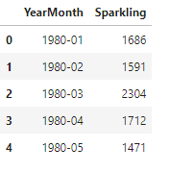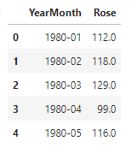
Table 1.1: Sample Data for Sparkling and Rose wines

From the above figure it is evident that, the values of the sparkling wine is higher than the values of the Rose wine. 15 years data from 1980 to 1995 has been provided to forecast the sales of Sparkling and Rose wine for next 12 months.

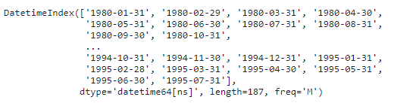
Table 1.2 : DateTimeIndex of Sparkling

Table 1.3 : DateTimeIndex of Rose
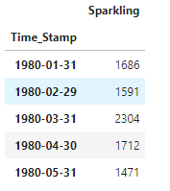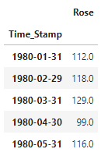
Table 1.4: Time Series Data for Sparkling and Rose wines
The raw data in Table 1.1 has been converted to Time Series data by indexing the Time Stamp Values.

Perform appropriate Exploratory Data Analysis to understand the data and also perform decomposition.

- Checking the Null Values:
- There are no null values in the Sparkling Wine data set.
- There are two null values in the Rose Wine data set.
- Let us analyse the trend and seasonality to impute the null values.
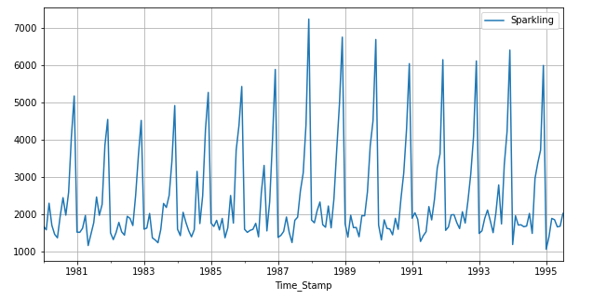
Fig 1.1: Time Series of Sparkling
- From the Sparkling Wine time series it is clear that is no trend in the sales but have seasonality we will further analyse the graph across the months in different years to check whether there is any trend present across the months in different years.
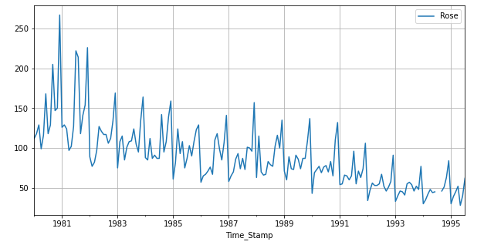
Fig 1.2: Time Series of Rose

- From the Rose Wine time series it is clear that is trend as well as seasonality present in the sales. We can also observe that, there is gap in the graph in the year 1994 and it is because of Null Values present in the dataset. As there is trend and Seasonality we will impute the null values accordingly.
- After imputing the Null Values by interpolating the data with Linear method the Time Series is as below:
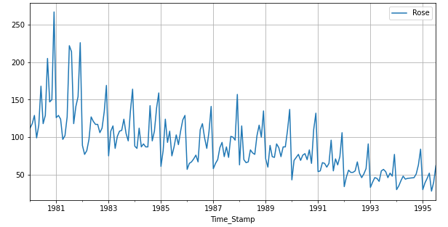
Fig 1.3: Null values treated Time Series of Rose
- Statistical Analysis of the Sparkling and Rose:
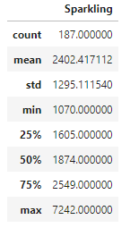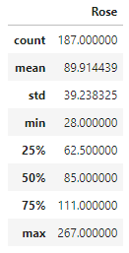
Table 1.5: Statistical Description of the Sparkling and Rose dataset
- From the above we can say that :
  - The sale value of Sparkling is higher than the sale value of Rose.
  - The Mean sale value of the Sparkling sale value stands at 2402.41 and the mean sale value of the Rose sale stands at 89.91. There is a huge difference between the sale values of both the wines.
  - Let us analyze the same with the Box Plot.
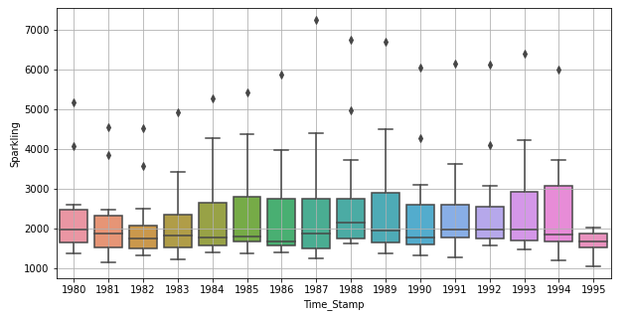
Fig: 1.4: Boxplot across years for sparkling
- From the above figure we can say that, there is no trend in the sales but, after the year 1983, most of the values lies more than 50% and the median value stays at close to 2000. The maximum sale happened in the year 1987 with highest value.
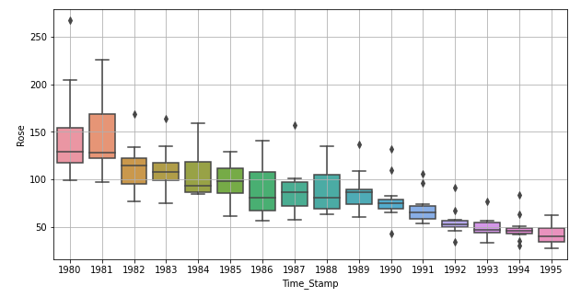
Fig: 1.5: Boxplot across years for Rose
- From the above figure we can say that, there is decreasing trend in the sales for Rose wine as such the median values varies across the years with respect to the trend in sales. The maximum sales happened in the year 1980.
- Let is understand the spread of sales across different years and within different months across years for both sparkling and rose wines:
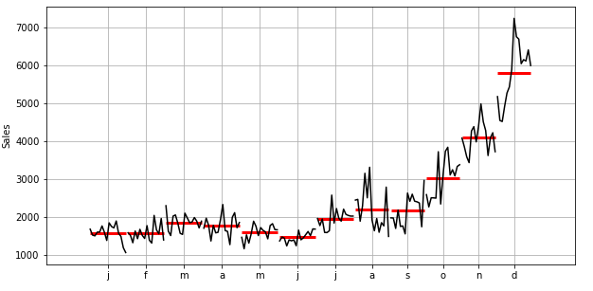
Fig: 1.6: Month wise analysis for sparkling
- From the above figure we can analyze the sales for the sparkling wines are high in the month of December. The sales have been increased exponentially from the month of September to December up to 7000 whereas the January month sales are as low as less than 2000.
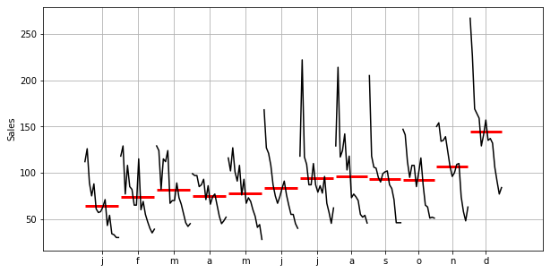
Fig: 1.7: Month wise analysis for Rose
- From the above figure, the average wine sales of Rose is in and around same across all the months and there was a slightest increase of sales in the Months of July, August and December Months.
- Let us also look at the trend analysis across all the years for both Sparkling and Rose.
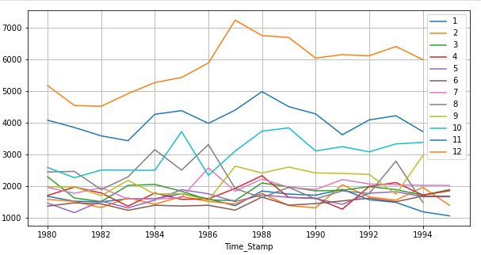
Fig: 1.8: Trend Analysis across Years for Sparkling
- From the above figure, the sales in December, November, October months are high.
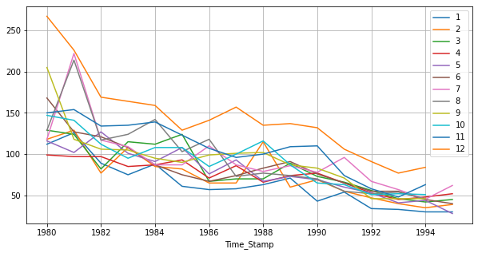
Fig: 1.9: Trend Analysis across Years for Rose
- The sale in the December month are high compared to all other months.
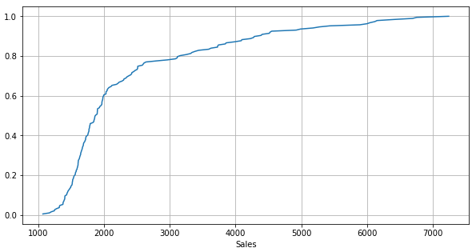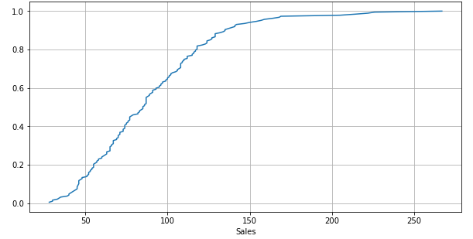
Fig: 1.10: Percentage of Datapoints
- From the above data we can say that more than 80% of data points lies above the 3000 sales for sparkling wine.
- More than 80% of the data points lie more than 15 sales for Rose wine.
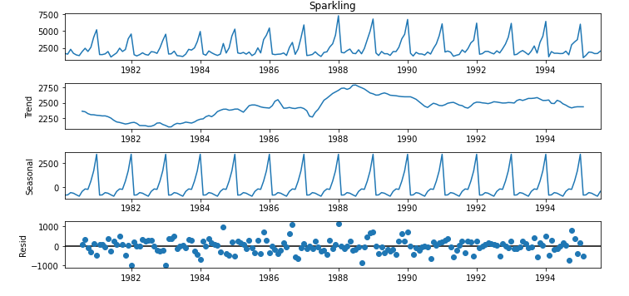
Fig: 1.11: Decomposition of Time Series-Additive-Sparkling

- From the above figure, the residual points is close to zero and does not follw any patter.
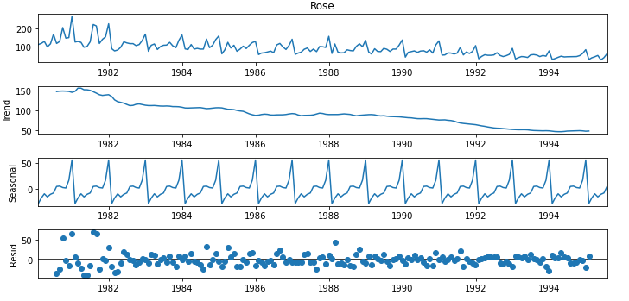
Fig: 1.12: Decomposition of Time Series-Additive-Rose
- From the above figure, the residual points is close to zero and does not follow any patter.

Let us see the multiplicative time series decomposition as well.
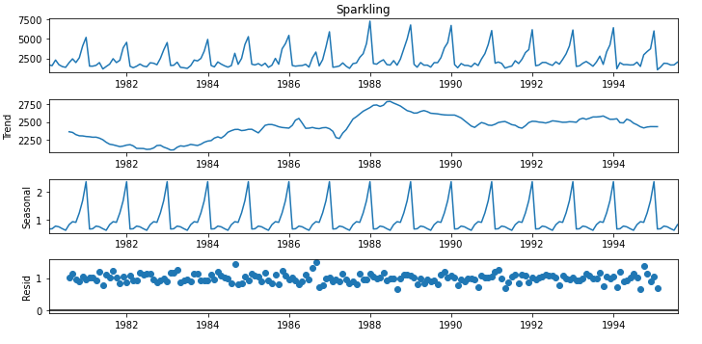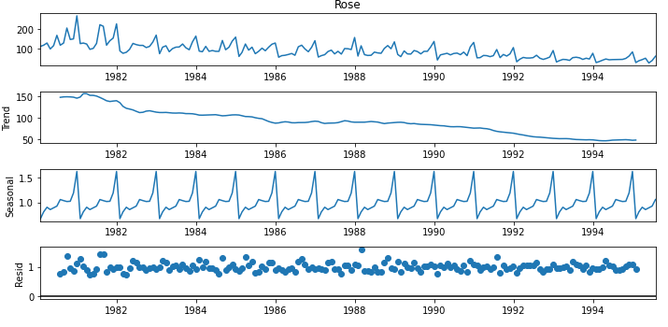
Fig: 1.13: Decomposition of Time Series-Multiplicative-Rose & Sparkling
Observing both additive and multiplicative decompositions, the residual points in multiplicative decomposition does not show any pattern and are much closer to to zero compared to the additive decomposition. And also the seasonality is multiplicative in both the Sparkling and Rose wine sales. So going ahead we will be using the Multiplicative method to forecast and to achieve the Objective.

Split the data into training and test. The test data should start in 1991.

The data set has been split into the Training and Test Data.
- Training Data contains the Years with Sales values < 1991
- Test Data Contains the Years with Sales values >= 1991.
The Shape of the data set after splitting the data sets into Training and Test is as below:
- Training Data: 132 Rows with One Column.
- Test Data: 55 Rows with One Column.

Let us now visualize the Train and Test data through Time Series Graph.

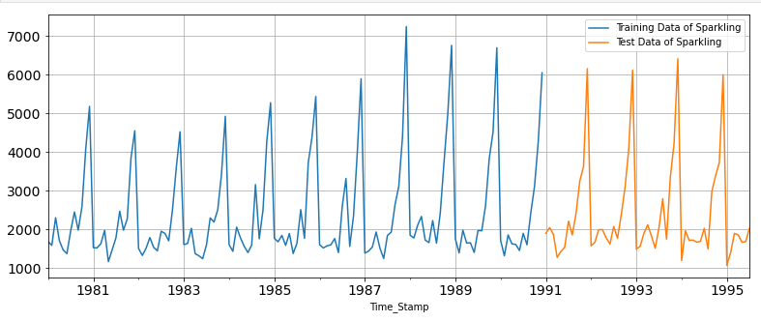
Fig: 1.14: Train and Test Data of Sparkling
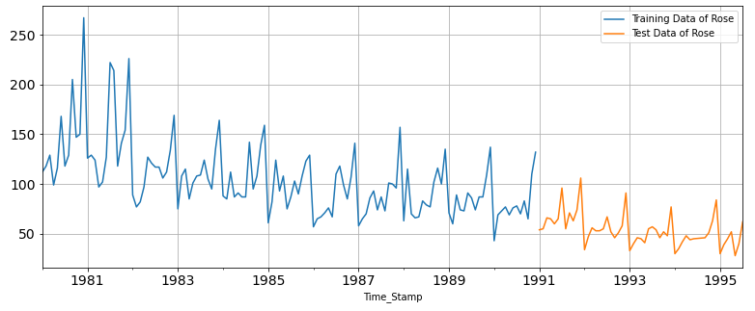
Fig: 1.15: Train and Test Data of Rose

Build various exponential smoothing models on the training data and evaluate the model using RMSE on the test data. Other models such as regression,naïve forecast models, simple average models etc. should also be built on the training data and check the performance on the test data using RMSE.

In all the Models we perform the Model on the train data and evaluate the Model on the test data. Let us start with the regression:

REGRESSION:

We have fit the Model on Linear Regression on Train data. The graphs are as below:

FOR SPARKLING DATASET:

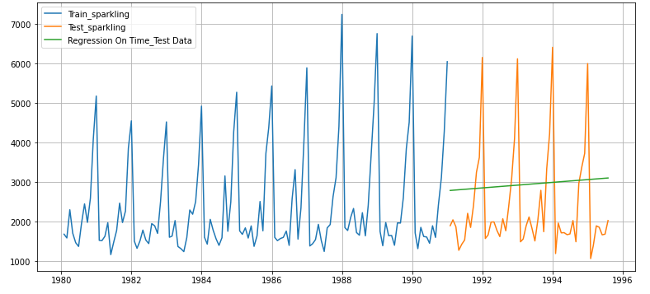
Fig: 1.16: Linear Regression Sparkling

The best fit line of the Linear Regression the data is as above. Let us calculate the Root mean Squared Error (RMSE) and Mean Absolute Percentage Error (MAPE).

RMSE: is the standard deviation of the residuals (Prediction errors). Residuals are measure of how far from the regression line data points are: RMSE is Measure of how spread these residuals are.
MAPE: Is how far the models predictions are off from their corresponding output Average.

Understanding the RMSE and MAPE’s the Values of RMSE and MAPE for Linear Regression is:

RMSE: 1389.135
MAPE: 59.55%

FOR ROSE DATASET:
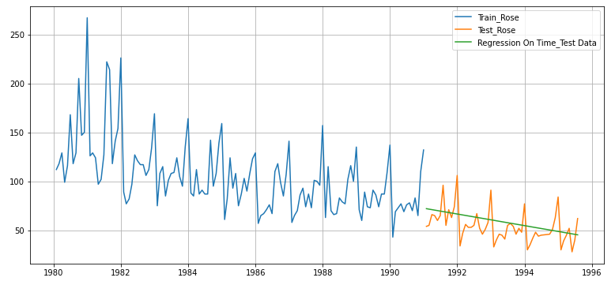

Fig: 1.17: Linear Regression Rose
The best fit line of the Linear Regression the data is as above. Let us calculate the Root mean Squared Error (RMSE) and Mean Absolute Percentage Error (MAPE).

RMSE: 15.269
MAPE: 24.95

NAÏVE MODEL: Yhat t+1=yt

For this particular naive model, we say that the prediction for tomorrow is the same as today and the prediction for day after tomorrow is tomorrow and since the prediction of tomorrow is same as today, therefore the prediction for day after tomorrow is also today.

Let us visualize same through the graph:

The Value Indexed at 130 will be the future forecast.

NAÏVE Approach– Sparkling:
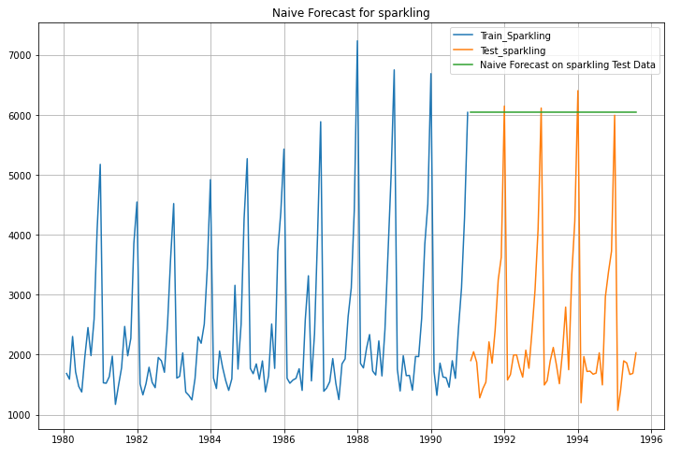
Fig: 1.18: Naïve Approach-Sparkling
From the above figure we can see that, the forecast is at 6047. Let us look at the RMSE and MAPE Scores for NAÏVE Approach.
RMSE: 3864.279
MAPE: 201.33
NAÏVE Approach – Rose:
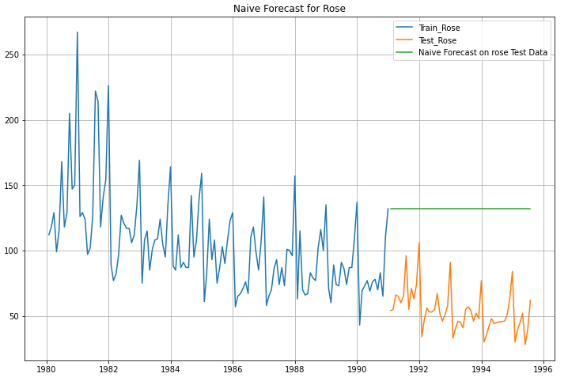
Fig: 1.19: Naïve Approach-Rose
From the above figure we can see that, the forecast is at 132. Let us look at the RMSE and MAPE Scores for NAÏVE Approach.
Here even though there is trend and Seasonality in the sales across years the forecast is showing at 132 and there is huge difference in the forecasted value and the Test data Value. This model per se is not suitable for the dataset having trend and Seasonality.
RMSE: 79.719
MAPE: 164.85
SIMPLE AVERAGE METHOD for SPARKLING:
In a simple Average Method, the average of all 15 years is taken and forecasted to next years.
Let us visualize the graph:

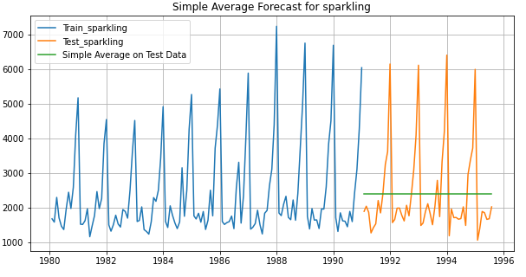
Fig: 1.20: Simple Average-Sparkling
The Model Evaluation on the test data is shown in the above figure. Though the simple Average Model is easy to compute and forecast but some time the model may miss out the trend and seasonality.
The RMSE and MAPE Values are as below:

RMSE: 1275.081
MAPE: 39.157

SIMPLE AVERAGE for ROSE:

The Model Evaluation on the test data for Rose wine sale is shown below:
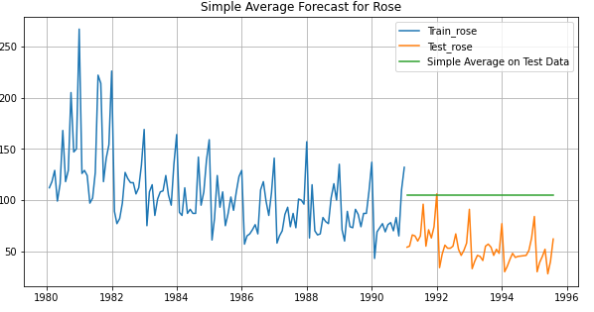
Fig: 1.21: Simple Average-Rose

MOVING AVERAGE for SPARKLING:

For the moving average model, we are going to calculate rolling means (or moving averages) for different intervals. The best interval can be determined by the maximum accuracy (or the minimum error) over here.

Here the Moving Average is calculated for 2,4,6 and 9 Intervals and the performance on the train data is as below:
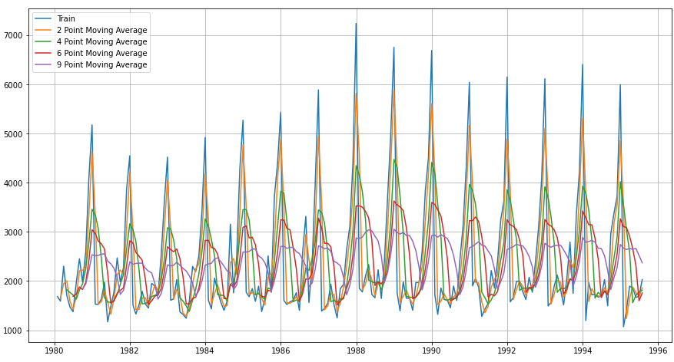

Fig: 1.22: Moving Average-Train Data-Sparkling
From the above figure it is evident that, 2 point moving average is having better compared to other moving average. 2 Point moving average also considering the seasonality across years on same line with the Train data.
Let us evaluate the model on the test data:
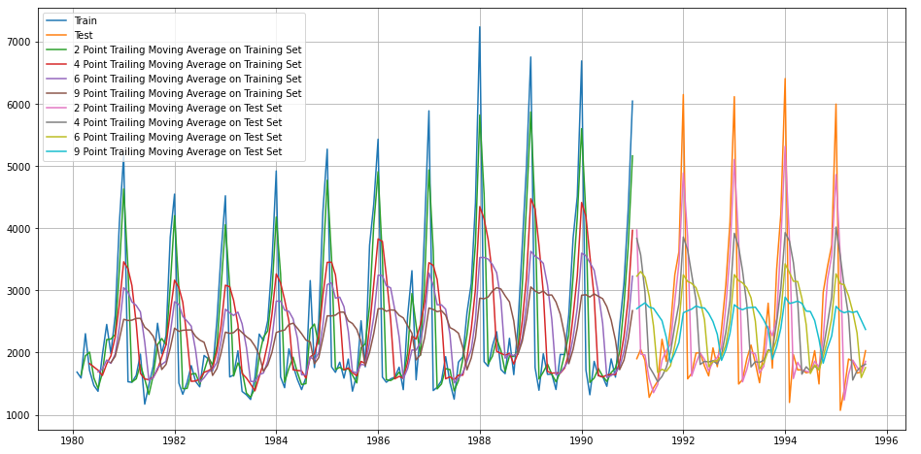
Fig: 1.23: Moving Average-Test Data-Sparkling
It is evident from the above figure that, the Model is having the better accuracy with the 2 point Moving Average considering the seasonality as well.

Let us calculate the RMSE and MAPE values for all the 2,4,6,9, Moving Averages:

From the above calculated RMSE and MAPE values it is clear that, 2 point moving average have minimum errors and maximum accuracy as the RMSE and MAPE Values are low compared to other three.

MOVING AVERAGE for Rose:

For the moving average model, we are going to calculate rolling means (or moving averages) for different intervals. The best interval can be determined by the maximum accuracy (or the minimum error) over here.

Here the Moving Average is calculated for 2,4,6 and 9 Intervals and the performance on the train data is as below:
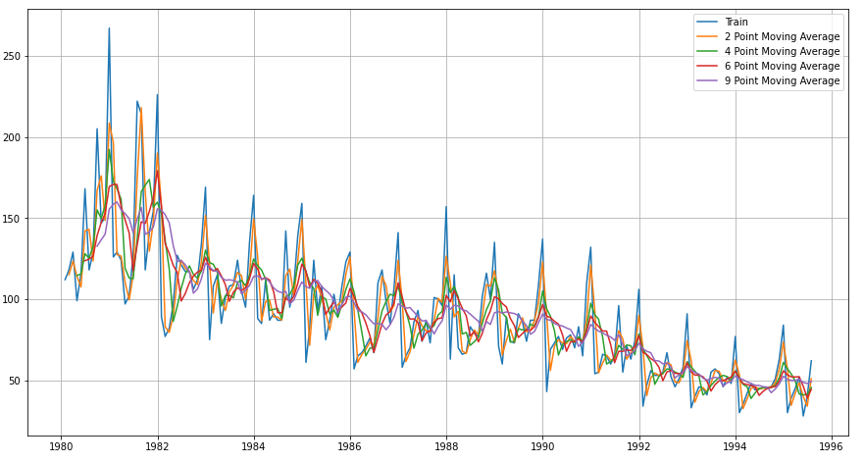

Fig: 1.24: Moving Average-Train Data-Rose
From the above figure it is evident that, 2 point moving average is having better compared to other moving average. 2 Point moving average also considering the seasonality across years on same line with the Train data.
Let us evaluate the model on the test data:
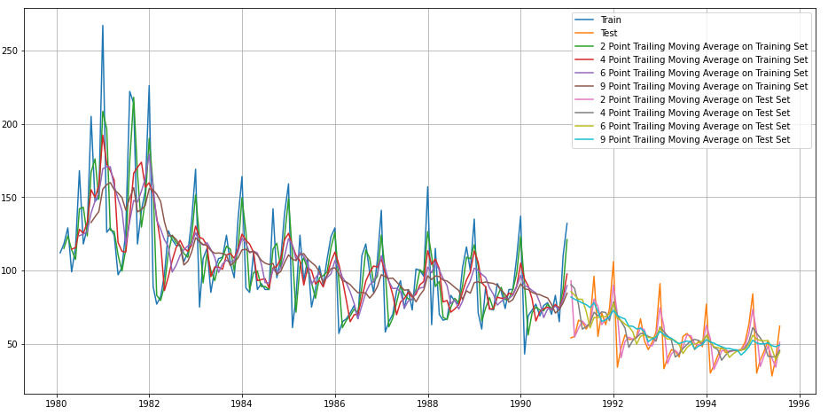
Fig: 1.25: Moving Average-Test Data-Rose
It is evident from the above figure that, the Model is having the better accuracy with the 2 point Moving Average considering the seasonality as well.

Let us calculate the RMSE and MAPE values for all the 2,4,6,9, Moving Averages:

From the above calculated RMSE and MAPE values it is clear that, 2 point moving average have minimum errors and maximum accuracy as the RMSE and MAPE Values are low compared to other three moving averages.

Model Comparison among the Linear Regression, Niave, Simple Average, Moving Averages of SPARKLING:

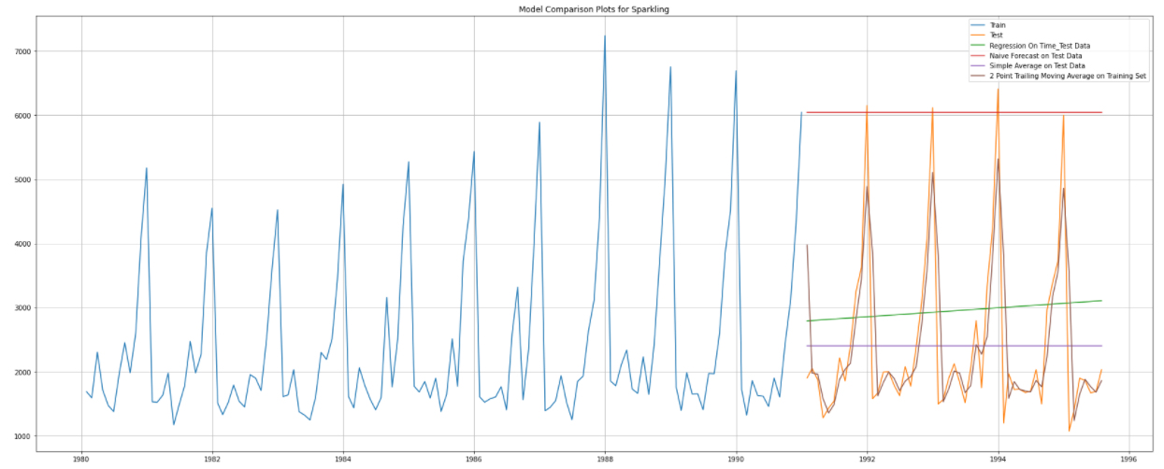
Fig: 1.26: Model Comparison –Sparkling
Comparing all the Models it is evident that 2 point moving average is performing better and having better accuracy.

Model Comparison among the Linear Regression, Niave, Simple Average, Moving Averages of Rose:

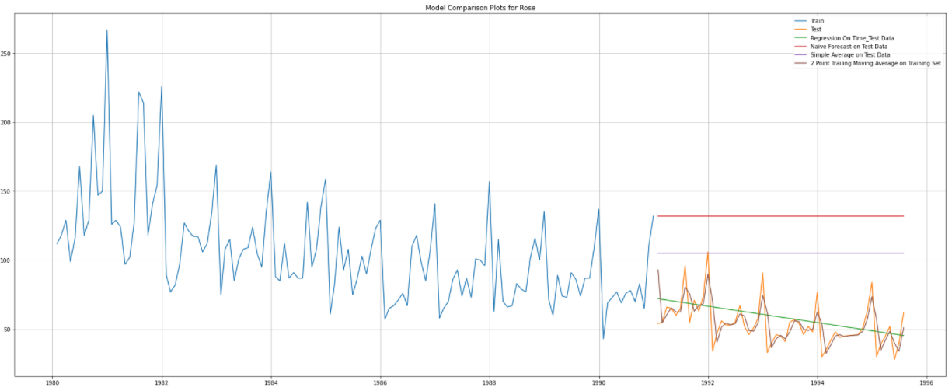
Fig: 1.27: Model Comparison - Rose
Comparing all the Models it is evident that 2 point moving average is performing better and having better accuracy having both trend and seasonality.

EXPONENTIAL SMOOTING METHODS – Sparkling
Simple Exponential Smoothing Method: For Simple Exponential Smoothing Methods, the autofit parameters have taken into consideration. It is a tie series forecasting method for univariate data without trend or seasonality. It requires a single parameter called Alpha, also called the smoothing parameter or smoothing coefficient.
The parameters inside the Simple Exponential Model are:
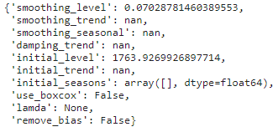
In the particular Sparkling dataset, the smoothing parameter or smoothing coefficient is at 0.07
At Aplha = 0.07 the forecasted value is 2804.6627, let us visualize the graph:
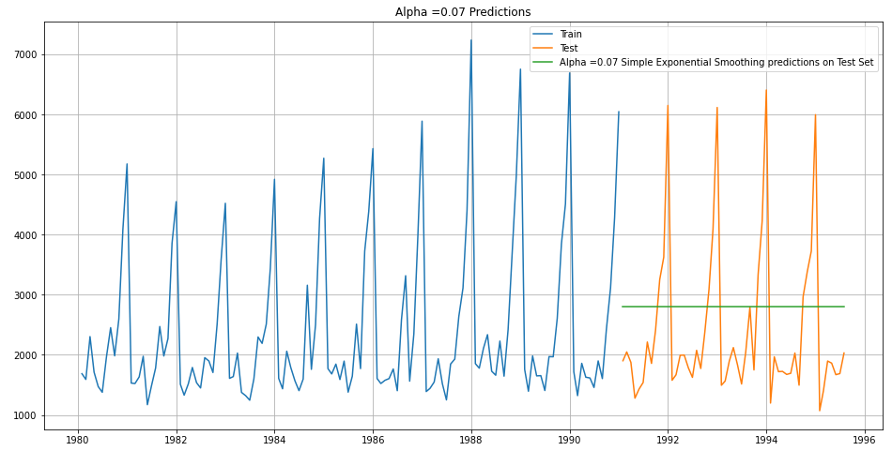
Fig: 1.28: SES – Sparkling
The RMSE and MAPE Values are:
RMSE: 1330.005
MAPE: 53.88
Let us calculate the RMSE and MAPE Values for the values ranging between 0.3 to 1 with an increment of 0.1 overtime.

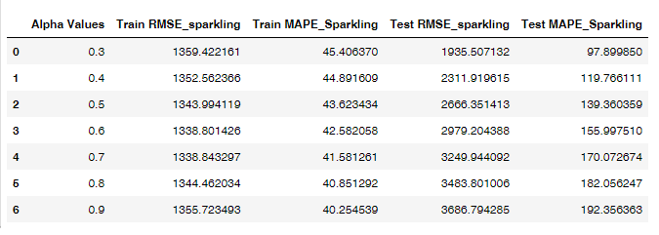
Table: 1.6: SES – RMSE and MAPE Values for the range(0.3 to 0.9)
From the above table, it is evident that, the Alpha value at 0.3 having the best accuracy will less errors compared to others. Let us visualize the same.
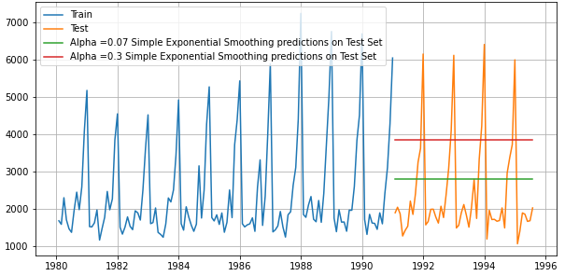
Fig: 1.29: SES – Sparkling @ 0.07 and 0.3
From the above comparison the simple exponential smoothing @0.07 is showing some better performance than the alpha value @0.3
DOUBLE EXPONENTIAL Smoothing Method: Double Exponential smoothing employs a level component and a trend component at each period having the both Aplha and Beta values.
For better forecasting the alpha and the beta values have given in the range on 0.3 to 0.1, the RMSE and MAPE Scores are as below:
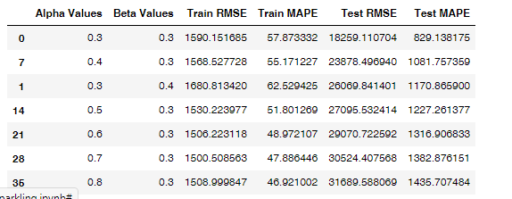
Table: 1.7: DES– RMSE and MAPE Values for the range (0.3 to 0.9)
From the above table, it is evident that, the RMSE and MAPE values are low and model is having good accuracy at Aplha @ 0.3 and Beta @ 0.3. Let us visualize the model :
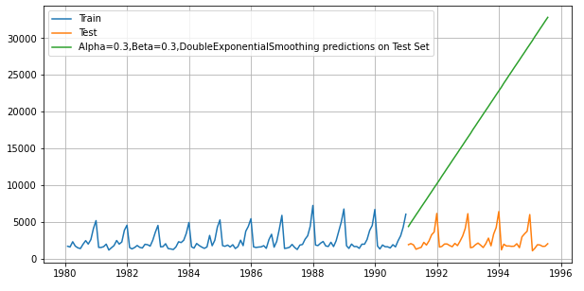
Fig. 1.30: DES- Sparkling – Alpha @ 0.3 and Beta @0.3
The forecasted value in the above figure is showing a bit contrast to the time series trend and seasonality of the Sparkling Wine Sales. The forecasted value on the test data is much larger than the actual values of test as in double exponential smoothing the forecast value will not take seasonality into consideration.
Let us further analyze the model with Triple exponential smoothing:
TRIPLE EXPONENTIAL SMOOTHING:
Triple Exponential Smoothing is an extension of Exponential Smoothing that explicitly adds support for seasonality to the univariate time series. This method is sometimes called Holt-Winters Exponential Smoothing.
In Triple Exponential Smoothing there will be three values of Alpha, Beta and the Gamma.
The autofit parameters for the Triple Exponential Smoothing is as follows:
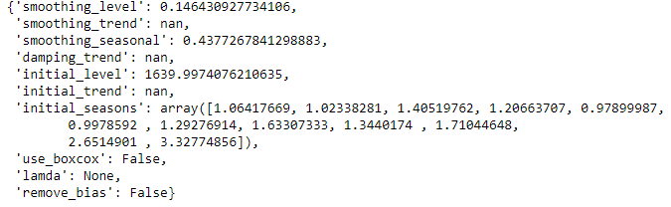
In this particular dataset the Sparkling Time Series have does not show any trend so in Triple Exponential Smoothing we have set the trend value as NaN.
Accordingly, the alpha value is 0.14 and Gamma Value is 0.4377
From the above two values let us find forecast value for Sparkling wine
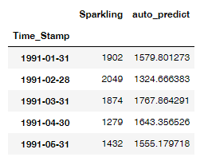
Table 1.8: Forecast Value for Sparkling wines at alpha and Gamma
Let us visualize the same:
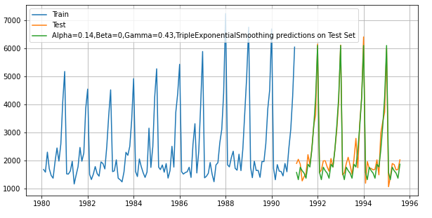
Fig. 1.31: TES- Sparkling – Alpha @ 0.14, Beta @ 0, Gamma @ 0.43
From the above figure it is evident that, the Triple Exponential Model is the given auto fitted values showing the less error and performing better on the Test Data as well.
RMSE and MAPE Scores for the same are:
RMSE: 322.210
MAPE: 12.292
Let us also try the Triple Exponential Model with the by giving the range of vales from 0.3 to 0.9. Accordingly, the RMSE and MAPE Scores are as below:
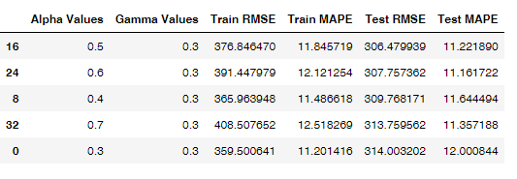
Table 1.9: RMSE and MAPE for Sparkling Wine
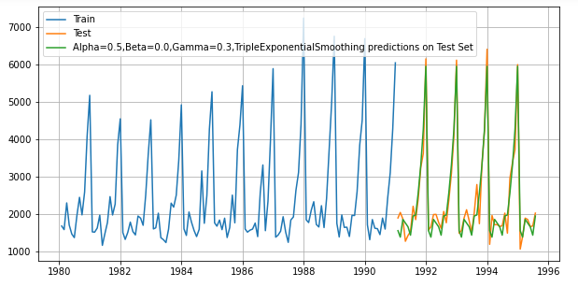
Fig. 1.32: TES- Sparkling – Alpha @ 0.5, Beta @ 0, Gamma @ 0.3
From the above figure it is evident that, the Triple Exponential Model is the given auto fitted values showing the less error and performing better on the Test Data as well.
RMSE and MAPE Scores for the same are:
RMSE: 306.4799
MAPE: 11.22
Both the Triple Exponential models with Auto fitted params and range of values the model is performing better compared other two exponential
 | RMSE | MAPE
Alpha @ 0.14, Beta @ 0, Gamma @ 0.43 | 322.210 | 306.4799
Alpha @ 0.5, Beta @ 0, Gamma @ 0.3 | 12.292 | 11.22

From the above Comparison table, we can say that, the Alpha @ 0.5, Beta @ 0, Gamma @ 0.3 is performing better than the auto fitted value.

EXPONENTIAL SMOOTING METHODS – Rose
Simple Exponential Smoothing Method: For Simple Exponential Smoothing Methods, the autofit parameters have taken into consideration. It is a tie series forecasting method for univariate data without trend or seasonality. It requires a single parameter called Alpha, also called the smoothing parameter or smoothing coefficient.
The parameters inside the Simple Exponential Model are:
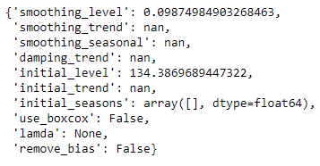
In the particular Rose dataset, the smoothing parameter or smoothing coefficient is at 0.09
At Aplha = 0.09 the forecasted value is 87.104998, let us visualize the graph:
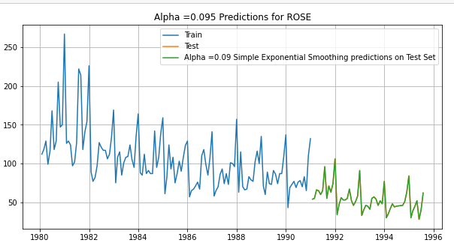
Fig: 1.33: SES – Rose
The RMSE and MAPE Values are:
RMSE: 36.796
MAPE: 75.9
Let us calculate the RMSE and MAPE Values for the values ranging between 0.3 to 1 with an increment of 0.1 overtime.
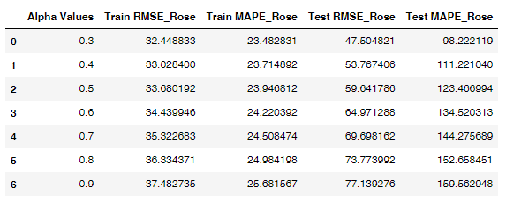
Table 1.10: SES – RMSE and MAPE Values for the range(0.3 to 0.9)
From the above table, it is evident that, the Alpha value at 0.3 having the best accuracy will less errors compared to others. Let us visualize the same.
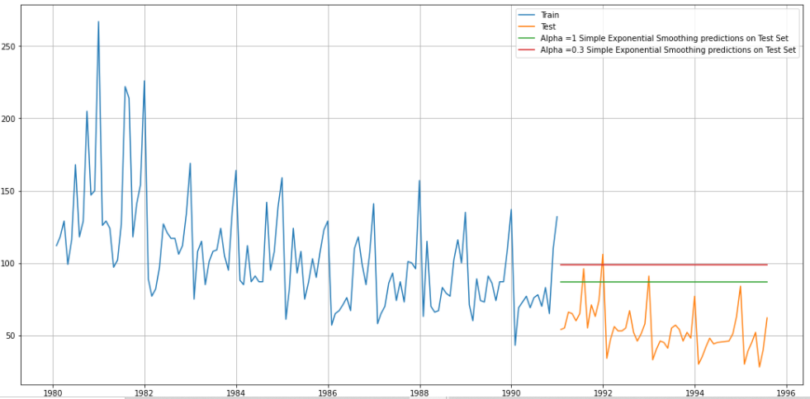
Fig: 1.34: SES – Rose @ 0.09 and 0.3
From the above comparison the simple exponential smoothing @0.09 is showing some better performance than the alpha value @0.3
DOUBLE EXPONENTIAL Smoothing Method: Double Exponential smoothing employs a level component and a trend component at each period having the both Aplha and Beta values.
For better forecasting the alpha and the beta values have given in the range on 0.3 to 0.1, the RMSE and MAPE Scores are as below:
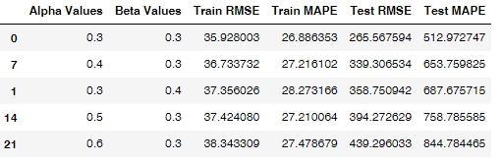
Table: 1.11: DES– RMSE and MAPE Values for the range (0.3 to 0.9)
From the above table, it is evident that, the RMSE and MAPE values are low and model is having good accuracy at Aplha @ 0.3 and Beta @ 0.3. Let us visualize the model :
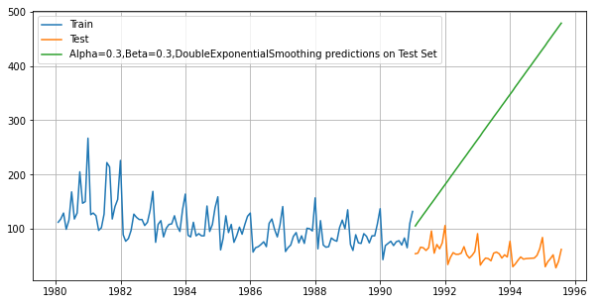
Fig. 1.35: DES- Rose – Alpha @ 0.3 and Beta @0.3
The forecasted value in the above figure is showing a bit contrast to the time series trend and seasonality of the Rose Wine Sales. The forecasted value on the test data is much larger than the actual values of test as in double exponential smoothing the forecast value will not take seasonality into consideration.
Let us further analyze the model with Triple exponential smoothing:
TRIPLE EXPONENTIAL SMOOTHING:
Triple Exponential Smoothing is an extension of Exponential Smoothing that explicitly adds support for seasonality to the univariate time series. This method is sometimes called Holt-Winters Exponential Smoothing.
In Triple Exponential Smoothing there will be three values of Alpha, Beta and the Gamma.
The autofit parameters for the Triple Exponential Smoothing is as follows:
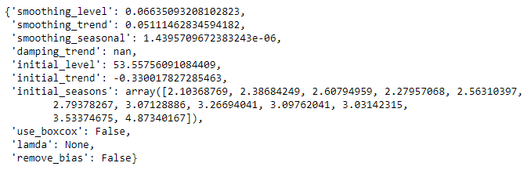
Accordingly, the alpha value is 0.14, Beta value is 0.05 and Gamma Value is 0.4377
From the above two values let us find forecast value for Rose wine
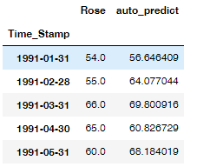
Table 1.12: Forecast Value for Sparkling wines at alpha, beta and Gamma
Let us visualize the same:
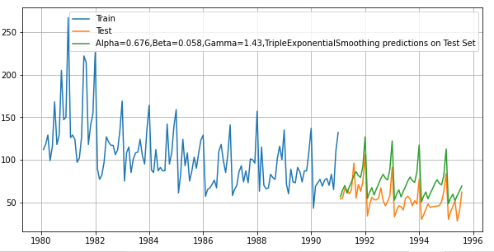
Fig. 1.36: TES- Rose – Alpha @ 0.67, Beta @ 0.05, Gamma @ 1.43
From the above figure it is evident that, the Triple Exponential Model is the given auto fitted values showing the less error and performing better on the Test Data as well.
RMSE and MAPE Scores for the same are:
RMSE: 20.931
MAPE: 38.5
Let us also try the Triple Exponential Model with the by giving the range of vales from 0.3 to 0.9. Accordingly, the RMSE and MAPE Scores are as below:
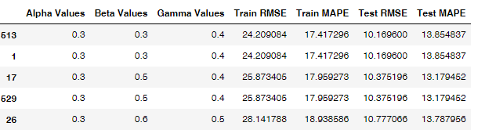
Table 1.13: RMSE and MAPE for Rose Wine
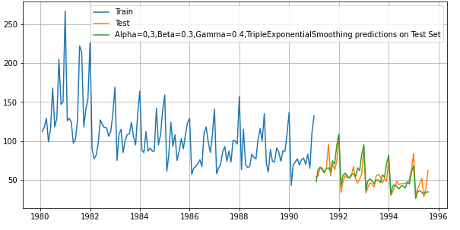
Fig. 1.37: TES- Rose – Alpha @ 0.3, Beta @ 0.3, Gamma @ 0.4
From the above figure it is evident that, the Triple Exponential Model is the given auto fitted values showing the less error and performing better on the Test Data as well.
RMSE and MAPE Scores for the same are:
RMSE: 10.1696
MAPE: 13.85
Both the Triple Exponential models with Auto fitted params and range of values the model is performing better compared other two exponential
 | RMSE | MAPE
Alpha @ 0.67, Beta @ 0.05, Gamma @ 1.43 | 20.931 | 38.5
Alpha @ 0.3, Beta @ 0.3, Gamma @ 0.4 | 10.1696 | 13.85

From the above Comparison table, we can say that, the Alpha @ 0.3, Beta @ 0.3, Gamma @ 0.4 is performing better than the auto fitted value.

Evaluating all three models at once on the test data:
EXPONENEITAL SMOOTING on SPARKLING:
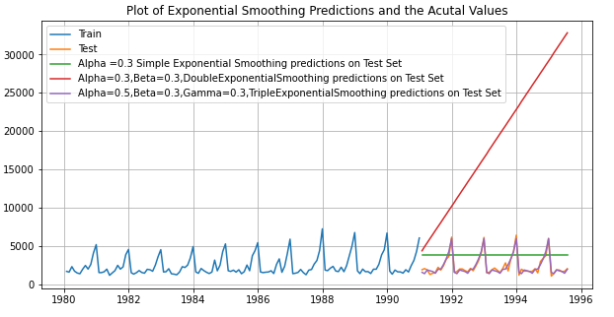
EXPONENEITAL SMOOTING on Rose:
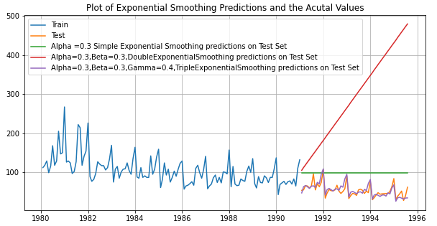
From the above two figures we can analyse that the triple exponential is performing better and having less errors in both Sparkling and Rose wine sales.

All Model Comparison
Sparkling
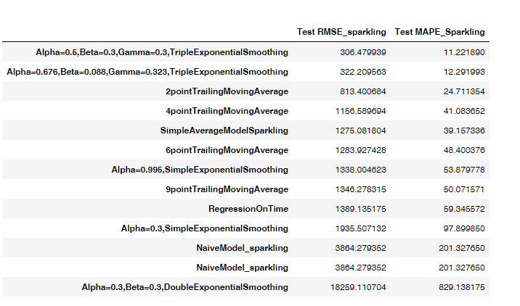
Rose
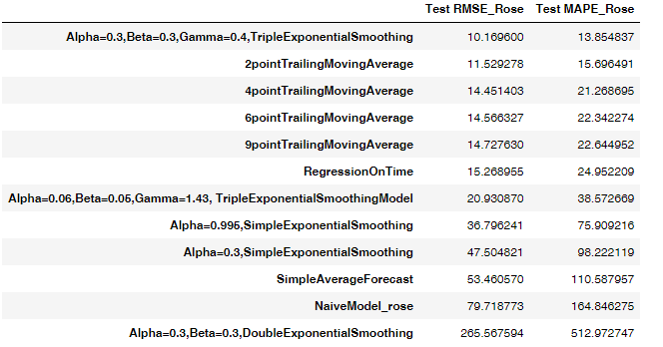

Check for the stationarity of the data on which the model is being built on using appropriate statistical tests and also mention the hypothesis for the statistical test. If the data is found to be non-stationary, take appropriate steps to make it stationary. Check the new data for stationarity and comment.
A Time Series is considered to be stationary whose statistical properties such as the variance & Auto correlation are all constant overtime.
To check the a series is stationary we Augmented Dickey Fuller (ADF) test whose Null and Alternate Hypothesis can be simplified to:
- Null Hypothesis (H0) : Time Series is not Stationary (alpha value at 0.05)
- Alternate Hypothesis (Ha): Time Series is Stationary (alpha value at 0.05)
ADF Works on the principal of finding the probability that a unit root is present in the AR Model. If the unit root is present in a time series, the time series shows a systematic pattern which is unpredictable thereby violating the idea of a stationary time series.
Lets us perform the ADF test by measuring the Rolling Means and Standard Deviation and visualize the same.

STATIONARY CHECK for SPARKLING:
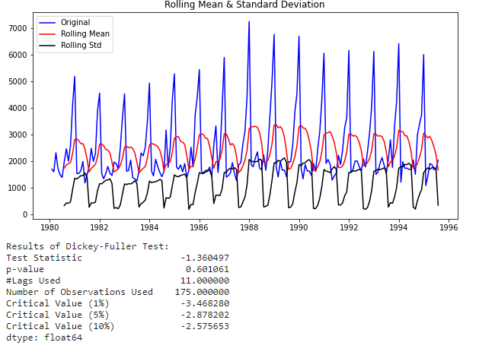
Fig 1.38: ADF Test for Sparkling wine
Let us check the P value with Alternate and Null hypothesis.
The P value obtained from ADF test is 0.60
Here in this test we fail reject the Null Hypothesis and it says that Time Series is not stationary.
For making the Time Series Stationary we need to apply the differencing method where the differences are computed between the consecutive observations.
After performing the differencing method to make the Time Series stationary the results are as follows:
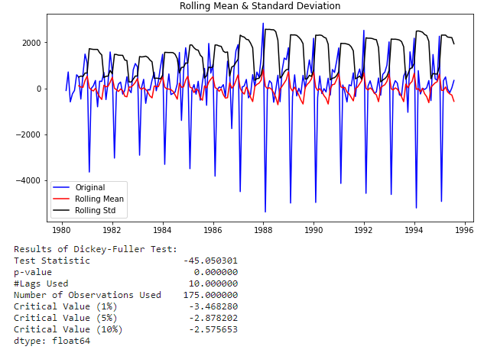
Fig 1.39: ADF Test for Sparkling wine after differencing
The P value is less than 0.05 at confidence of 0.95 and the Null Hypothesis is rejected and Time series is stationary.
SAPRKLING – ADF on Train Data Set:
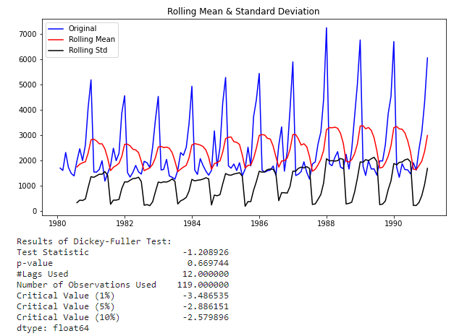
Fig 1.40: ADF Test for Sparkling wine Train Dataset
Let us check the P value with Alternate and Null hypothesis.
The P value obtained from ADF test is 0.60
Here in this test we fail reject the Null Hypothesis and it says that Time Series is not stationary.
For making the Time Series Stationary we need to apply the differencing method where the differences are computed between the consecutive observations.
After performing the differencing method to make the Time Series stationary the results are as follows:
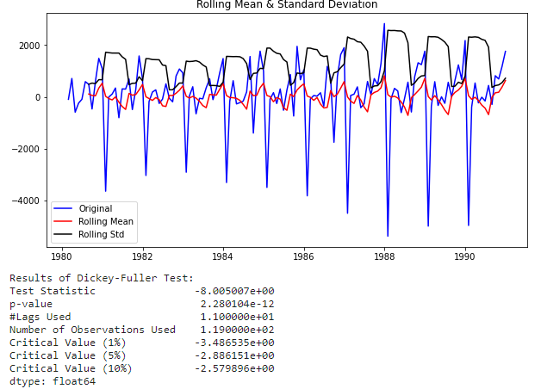
Fig 1.41: ADF Test for Sparkling wine Train Dataset after differencing
The P value is less than 0.05 at confidence of 0.95 and the Null Hypothesis is rejected and Time series is stationary

STATIONARY CHECK for ROSE Dataset:
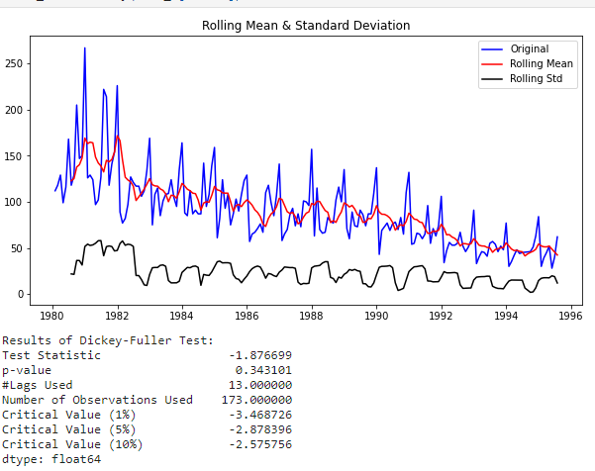
Fig 1.42: ADF Test for Rose wine
Let us check the P value with Alternate and Null hypothesis.
The P value obtained from ADF test is 0.34
Here in this test we fail reject the Null Hypothesis and it says that Time Series is not stationary.
For making the Time Series Stationary we need to apply the differencing method where the differences are computed between the consecutive observations.
After performing the differencing method to make the Time Series stationary the results are as follows:
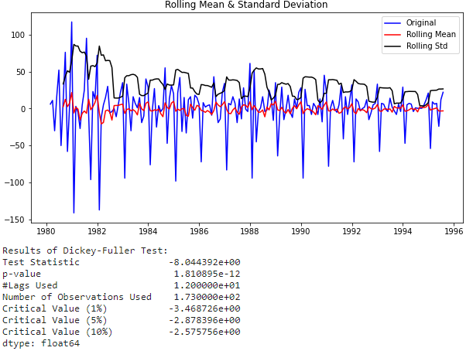
Fig 1.43: ADF Test for Rose wine after differencing
The P value is less than 0.05 at confidence of 0.95 and the Null Hypothesis is rejected and Time series is stationary.
ROSE – ADF on Train Data Set:
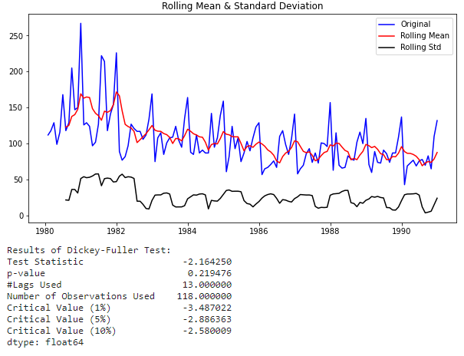
Fig 1.44: ADF Test for Rose wine Train Dataset
Let us check the P value with Alternate and Null hypothesis.
The P value obtained from ADF test is 0.21
Here in this test we fail reject the Null Hypothesis and it says that Time Series is not stationary.
For making the Time Series Stationary we need to apply the differencing method where the differences are computed between the consecutive observations.
After performing the differencing method to make the Time Series stationary the results are as follows:
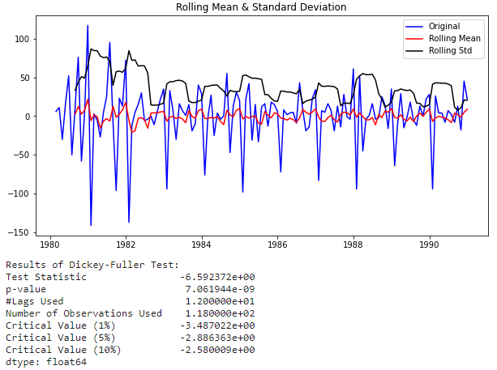
Fig 1.45: ADF Test for Rose wine Train Dataset after differencing
The P value is less than 0.05 at confidence of 0.95 and the Null Hypothesis is rejected and Time series is stationary

Build an automated version of the ARIMA/SARIMA model in which the parameters are selected using the lowest Akaike Information Criteria (AIC) on the training data and evaluate this model on the test data using RMSE.
Building the Automated version of ARIMA and SARIMA Model starting with Iter tools
The P and Q parameters have been ranges from 0 to 3 with the difference range of (1,2)

Some parameter combinations of the Model are:
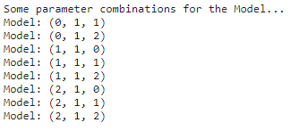
SPARKLING Dataset:
The automated ARIMA Models has been done on the training dataset of the Sparkling wine and the AIC Scores for the different set of ARIMA Parameters are as below:
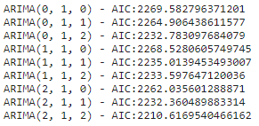
The lowest value of AIC when sorted are as follows:

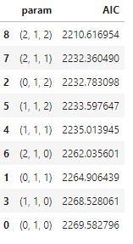
The values of the p,d,q has been set to (2,1,2) having the lowest AIC value of 2210.6169
From the above p,d,q values the Summary report analysis of Automated ARIMA is as follows:
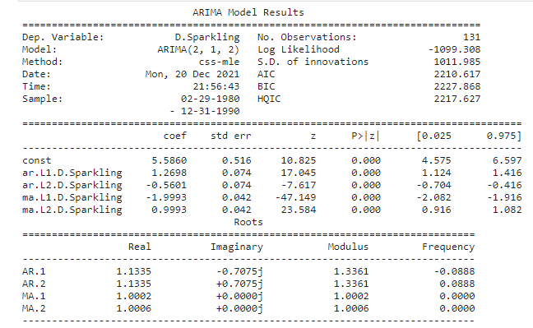
Table: 1.14: Summary report ARIMA Model – Sparkling Dataset

- All the Coefficients mentioned in the report like ar’s and MA’s are all statistically significant o make the better forecast as the p values are less than the significance level of 0.05.
- The higher the Log-Likelihood is better the model. As the log likelihood seems very less the model is performing better.
- Lowest AIC is a good way to choose the nest model.
- From the summary we can say that the std.error is also less.
The RMSE Score on the test data stand at 1375.028.
ROSE – Dataset:
The automated ARIMA Models has been done on the training dataset of the Rose wine and the AIC Scores for the different set of ARIMA Parameters are as below:
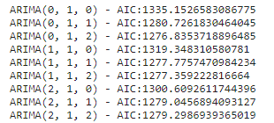
The lowest value of AIC when sorted are as follows:

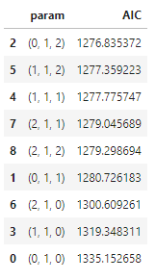
The values of the p,d,q has been set to (0,1,2) having the lowest AIC value of 1276.83
From the above p,d,q values the Summary report analysis of Automated ARIMA is as follows:
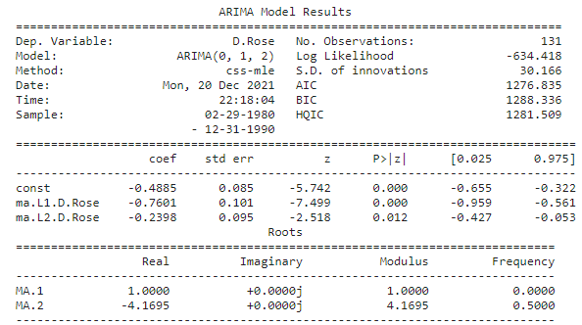
Table: 1.15: Summary report ARIMA Model – Rose Dataset

- All the Coefficients mentioned in the report like ar’s and MA’s are all statistically significant o make the better forecast as the p values are less than the significance level of 0.05.
- The higher the Log-Likelihood is better the model. As the log likelihood seems very less the model is performing better.
- Lowest AIC is a good way to choose the nest model.
- From the summary we can say that the std.error is also less.
The RMSE Score on the test data stand at 15.6177

Build ARIMA/SARIMA models based on the cut-off points of ACF and PACF on the training data and evaluate this model on the test data using RMSE.

As we have seen in the above question that, we have built the automated version of ARIMA/SARIMA value in which the parameters were chosen on the lowest AIC. Now we will plot the ACF and PACF graphs as see whether difference in the scores.
SPARKLING Dataset:
ACF and Differenced ACF:
ACF describes how well the present value of the series is related with its past value. ACF Considers all the components like trend, seasonality, cyclical and residual, hence it is called Complete Auto Correlation plot.
Differencing can help stabilise the mean of a time series by removing changes in the level of a time series, and therefore eliminating (or reducing) trend and seasonality.
As well as looking at the time plot of the data, the ACF plot is also useful for identifying non-stationary time series. For a stationary time series, the ACF will drop to zero relatively quickly, while the ACF of non-stationary data decreases slowly.

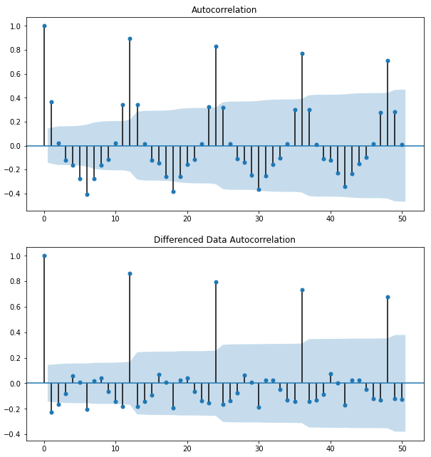
Fig 1.46: ACF and Differenced ACF of the Sparkling Dataset:

PACF: is a number which is the correlation between y & previous value of y with all intermediate values are conditioned & adjusted for.
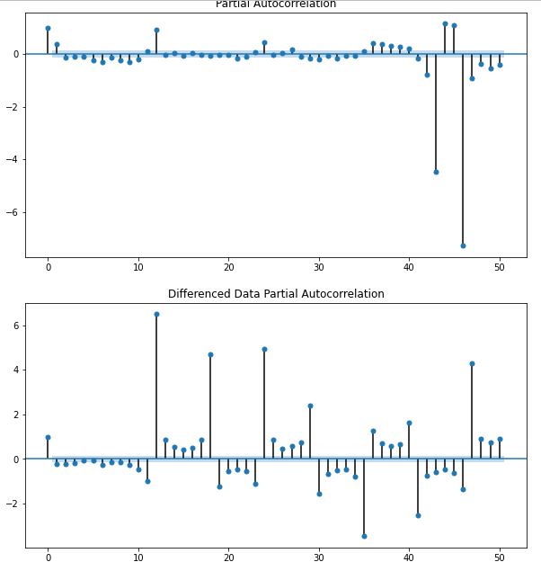
Fig 1.47: PACF and Differenced PACF of the Sparkling Dataset:
Build a version of the ARIMA model for which the best parameters are selected by looking at the ACF and the PACF plots.
No.of lags taken are 50
By observing the above Difference ACF and Differenced PACF the analysis are as follows:
Here, we have taken alpha=0.05.
The Auto-Regressive parameter in an ARIMA model is 'p' which comes from the significant lag before which the PACF plot cuts-off to 0. The Moving-Average parameter in an ARIMA model is 'q' which comes from the significant lag before the ACF plot cuts-off to 0. By looking at the above plots, we can say that both the PACF and ACF plot cuts-off at lag 0
The ARIMA Model summary is as follows:
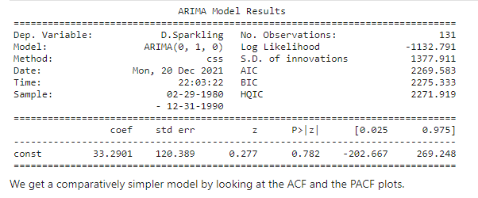
Table: 1.16: Summary report ARIMA Model (ACF/PACF) – Sparkling Dataset

- The statistical significant values are nor present from the values taken from the ACF and PACF cut offs
- The ARIMA Model is performing better on the values taken from the lowest AIC value.
- The RMSE Score on the Model is 4779.1542
Rose Dataset:
ACF and Differenced ACF:
ACF describes how well the present value of the series is related with its past value. ACF Considers all the components like trend, seasonality, cyclical and residual, hence it is called Complete Auto Correlation plot.
Differencing can help stabilise the mean of a time series by removing changes in the level of a time series, and therefore eliminating (or reducing) trend and seasonality.
As well as looking at the time plot of the data, the ACF plot is also useful for identifying non-stationary time series. For a stationary time series, the ACF will drop to zero relatively quickly, while the ACF of non-stationary data decreases slowly.

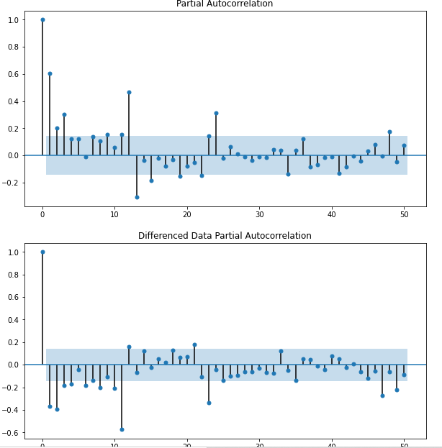
Fig 1.48: ACF and Differenced ACF of the Rose Dataset:

PACF: is a number which is the correlation between y & previous value of y with all intermediate values are conditioned & adjusted for.
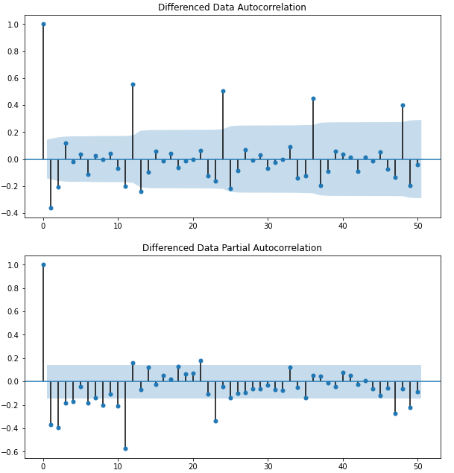
Fig 1.49: PACF and Differenced PACF of the Rose Dataset:
Build a version of the ARIMA model for which the best parameters are selected by looking at the ACF and the PACF plots.
No.of lags taken are 50
By observing the above Difference ACF and Differenced PACF the analysis are as follows:
Here, we have taken alpha=0.05.
The Auto-Regressive parameter in an ARIMA model is 'p' which comes from the significant lag before which the PACF plot cuts-off to 0. The Moving-Average parameter in an ARIMA model is 'q' which comes from the significant lag before the ACF plot cuts-off to 0. By looking at the above plots, we can say that both the PACF and ACF plot cuts-off at lag 0
The ARIMA Model summary is as follows:
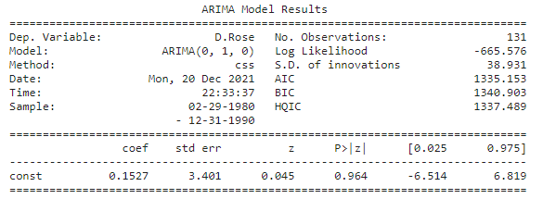
Table: 1.17: Summary report ARIMA Model (ACF/PACF) – Rose Dataset

- The statistical significant values are nor present from the values taken from the ACF and PACF cut offs
- The ARIMA Model is performing better on the values taken from the lowest AIC value.
- The RMSE Score on the Model is 84.13
Build an Automated version of a SARIMA model for which the best parameters are selected in accordance with the lowest Akaike Information Criteria (AIC) on Sparkling Dataset.

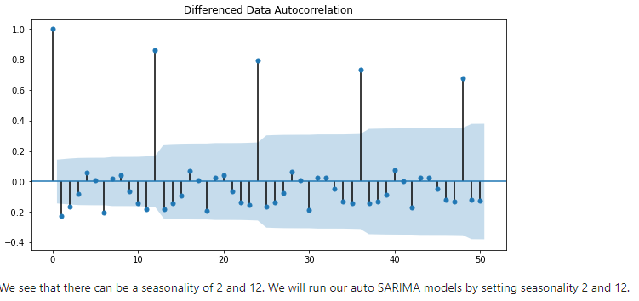

The lowest AIC of SARIMA on seasonality is as follows:
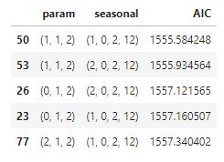
Basis the low AIC value the SARIMAX results are:
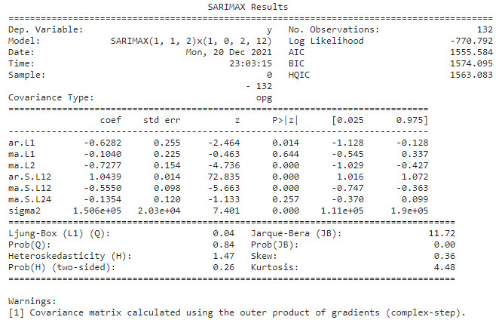
Table 1.18: SARIMAX Summary Sheet- Sparkling Dataset
- Most of the Coefficients mentioned in the report like ar’s and MA’s are all statistically significant o make the better forecast as the p values are less than the significance level of 0.05 except Moving Average L2 and Moving Average Seasonal L24.
- The higher the Log-Likelihood is better the model. The log likelihood is much lesse than the ARIMA Model of Sparkling data.
- Lowest AIC is a good way to choose the nest model.
- From the summary we can say that the std.error is also less.
The RMSE Score on the test data stand at 528.60.
We see that the RMSE value have reduced in SARIMA Model when the seasonality parameter was changed to 12.
We are going to take the seasonal period as 12. We will keep the p(1) and q(1) parameters same as the ARIMA model.
The Auto-Regressive parameter in an SARIMA model is 'P' which comes from the significant lag after which the PACF plot cuts-off to 0. The Moving-Average parameter in an SARIMA model is 'q' which comes from the significant lag after which the ACF plot cuts-off to 0. By looking at the plots we see that the ACF and the PACF do not directly cut-off to 0.

This is a common problem while building models by looking at the ACF and the PACF plots. But we are able to explain the model.

Build an Automated version of a SARIMA model for which the best parameters are selected in accordance with the lowest Akaike Information Criteria (AIC) on Sparkling Dataset.
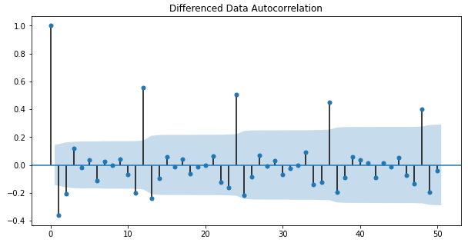

The lowest AIC of SARIMA on seasonality is as follows:
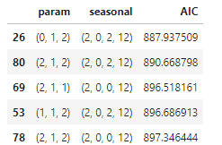

Basis the low AIC value the SARIMAX results are:
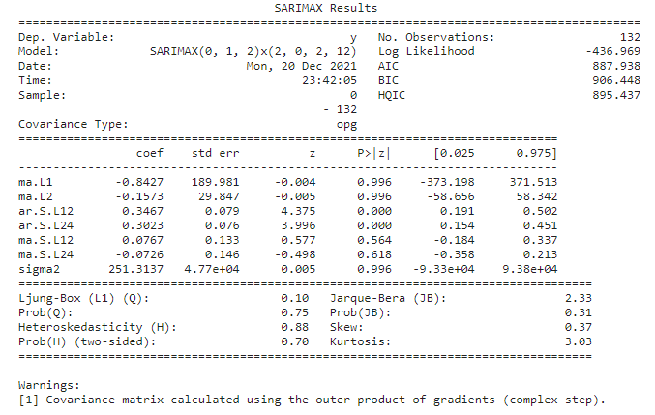
Table 1.19: SARIMAX Summary Sheet- Rose Dataset
- Only two variables are significant coefficients i.e., the ar.S. Values
- The higher the Log-Likelihood is better the model. The log likelihood is much lesser than the ARIMA Model of Sparkling data.
- Lowest AIC is a good way to choose the nest model.
- From the summary we can say that the std.error is also less.
The RMSE Score on the test data stand at 26.92
We see that the RMSE value have reduced in SARIMA Model when the seasonality parameter was changed to 12.
We are going to take the seasonal period as 12. We will keep the p(1) and q(1) parameters same as the ARIMA model.
The Auto-Regressive parameter in an SARIMA model is 'P' which comes from the significant lag after which the PACF plot cuts-off to 0. The Moving-Average parameter in an SARIMA model is 'q' which comes from the significant lag after which the ACF plot cuts-off to 0. By looking at the plots we see that the ACF and the PACF do not directly cut-off to 0.

Build a table (create a data frame) with all the models built along with their corresponding parameters and the respective RMSE values on the test data.
SPARKLING DataSet:
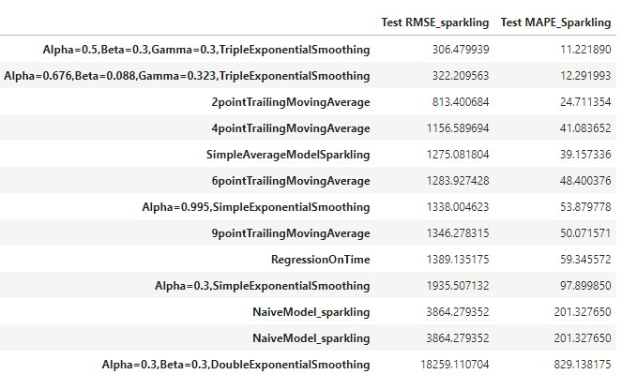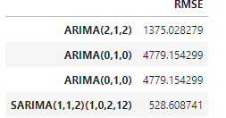
Table 1.20: Model Comparison – Sparkling
From the above table, it is evident that, the RMSE scores of Triple Exponential Scores are less and the Model will have better accuracy.

Rose DataSet:
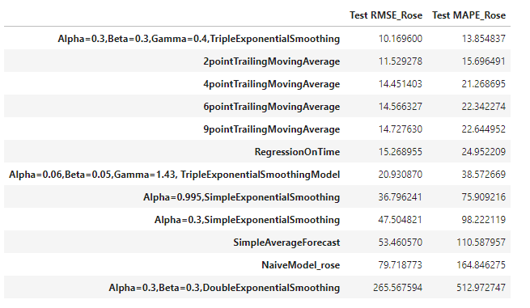
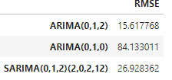
Table 1.21: Model Comparison- Rose
From the above table, it is evident that, the RMSE scores of Triple Exponential Scores are less and the Model will have better accuracy.

Based on the model-building exercise, build the most optimum model(s) on the complete data and predict 12 months into the future with appropriate confidence intervals/bands.

SPARKLING Dataset for 12 Months Forecast
At Triple Exponential smoothing_level=0.5, smoothing_trend=0.3, smoothing_seasonal=0.3 the RMSE Score on full data is 387.01 and the predictions for next 12 months is as follows:
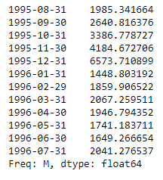
Table 1.22: Sparkling Forecast 12 months
The prediction plot is as below:
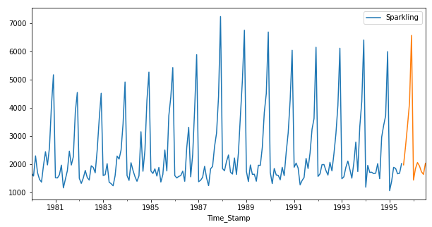
Fig: 1.50: Predicted Time Series – Sparkling
We have calculated the upper and lower confidence bands at 95% confidence level.
Here we are taking the multiplier to be 1.96 as we want to plot with respect to a 95% confidence intervals.

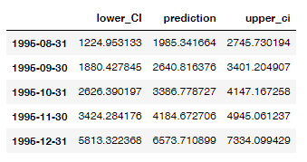
Table 1.23: Confidence Interval – Sparkling
The forecast along with the confidence band for next 12 months on Sparkling data set is:

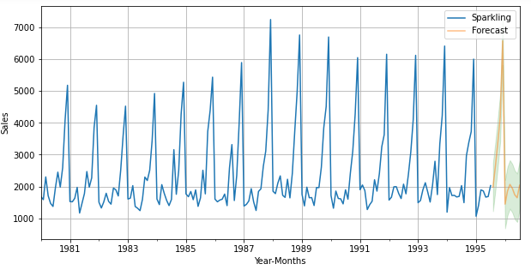
Fig: 1.51: Predicted Graph with Confidence Interval- Sparkling
ROSE Dataset – 12 Months Forecast:
At Triple Exponential smoothing_level=0.3, smoothing_trend=0.3, smoothing_seasonal=0.4 the RMSE Score on full data is 21.01 and the predictions for next 12 months is as follows:
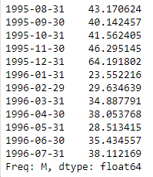
Table 1.24: Rose Forecast 12 months
The prediction plot is as below:
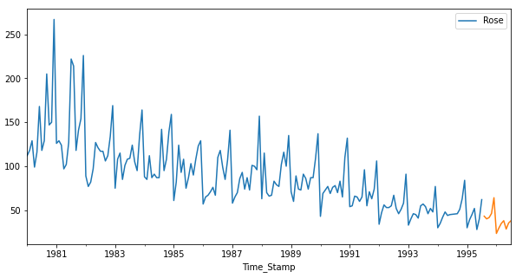
Fig 1.52: Predicted Time Series – Rose
We have calculated the upper and lower confidence bands at 95% confidence level.
Here we are taking the multiplier to be 1.96 as we want to plot with respect to a 95% confidence intervals.

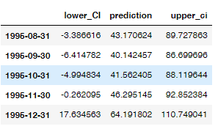
Table 1.25: Confidence Interval –Rose
The forecast along with the confidence band for next 12 months on Sparkling data set is:

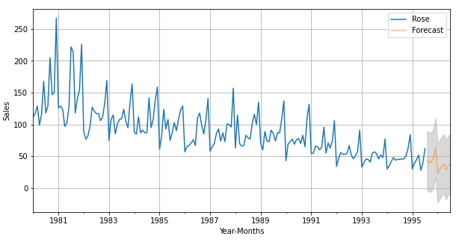
Fig: 1.53: Predicted Graph with Confidence Interval - Rose

Comment on the model thus built and report your findings and suggest the measures that the company should be taking for future sales.

In the given problem two Data sets have been given and asked to amylase the Times Series and forecast for Next 12 months.
In this we have performed various methods like EDA, Decomposition, Models like Simple Average, Linear Regression, Exponential Smoothing, Naïve, Moving Average has been performed with both auto fitted params and also with range of values give. Based on the outputs we have considered the lowest RMSE.
We also have calculated AIC Scores with and without ACF and PACF and performed models on the lowest values obtained from AIC Values. We also have plotted ACF and PACF plots and calculated the AIC using ACF and PACF.
The models have been performed on the Train Data and the model evaluation has been done on the Test Data.
The forecasted value is calculated performing all the models on test data the optimum models in this case the triple exponential models have been forecasted for further period of 12 months.
Sparkling Sales:
- We have observed that monthly sales across years and found that the sales are high in the month from September to December and the same trend and seasonality in the sales will continue for further months.
- To increase the number sales some discount offers or wine and few wine tasting exhibitions, membership offers and coupons may be provide in the months of January to August.
Rose Sales:
- It is observed that there is a decrease in trend of the sales from 1980 to 1945.
- Monthly sales across the years are more or less same but the overall sales are decreasing. To increase the sales discounts, coupons, one upon another free, good advertising, try to increase the taste are few solutions that can offered to this particular brand.
- Can also obtain a candid feedback from the customers on taste, price components to under further strategy to increase the sales.

